NAME
Replace this photo with your profile photo. To keep the size right, right-click on the image and select “change picture”, then choose your file
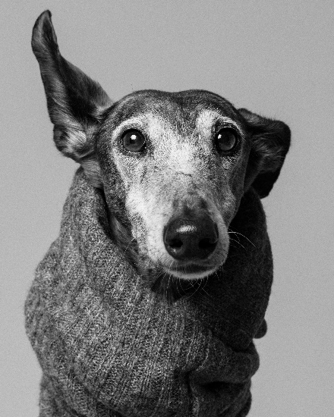
Email: (add your work email address)
Time Zone: GMT/BST (change if required)
Organisation: (add your institution)
Department: (add your department)
Teaching/research topics: (add topics you teach/research and interested in)

Courses/Modules with COIL element: (make sure this line always starts from this position)
ID | Name | Academic Level | Size | Next start | Potential COIL topics
Module ID  Hyperlink to module descriptor | Module name | Students in your module | Expected | Term (months), year | Existing project: projects that you have ran previously and are being repeated.  Potential new project: What would you like your COIL project to be about?
Add rows as required | Include only future projects

Other types of COIL projects (projects not embedded in an existing module): If you already have an idea – describe it here. If you do not, but would like to explore this option – indicate your interest. Otherwise, put N/A.

